**User Stories**

|  |  |  |
| --- | --- | --- |
| **Title**  **US - 1**: Environment Setup | **Priority**  1 | **Estimate** |
| **User Story**  As a: Product Owner,  I want the environment should be ready prior to the development  So that showcase of the prototype will be given as per the timeline. | | |
| **Acceptance Criteria**  Get the environment ready to develop the prototype. Below are the areas need to be setup before development and presented to the relevant stakeholders.   * Eclipse/IntelliJ: An IDE to code for the application * Java: A programming language to develop the prototype * Git: To connect and push files from the local system to GitHub * GitHub: To store the application code and track its versions | | |

|  |  |  |
| --- | --- | --- |
| **Title**  **US - 2**: Develop flow chart and Algorithm | **Priority**  2 | **Estimate** |
| **User Story**  As a: Project Manager,  I want the Algorithm and flow chart should be prepared  So that approach towards the solution can be freezed. | | |
| **Acceptance Criteria**  Algorithm and flow chart should be ready before the development. | | |
| **Title**  **US - 3**: Welcome Screen | **Priority**  1 | **Estimate** |
| **User Story**  As a: User,  Code to display the welcome screen. It should display:  Application name and the developer details  The details of the user interface such as options displaying the user interaction information  Features to accept the user input to select one of the options listed | | |
| **Acceptance Criteria**  Welcome Screen should be displayed with below details, Application name and the developer details ,user interface details and options. | | |

|  |  |  |
| --- | --- | --- |
| **Title**  **US - 4**: File names in ascending order | **Priority**  1 | **Estimate** |
| **User Story**  As a: User,  The first option should return the current file names in ascending order. The root directory can be either empty or contain few files or folders in it. | | |
| **Acceptance Criteria**  File names always be displayed in ascending order. | | |

|  |  |  |
| --- | --- | --- |
| **Title**  **US - 5**: Adding new file. | **Priority**  1 | **Estimate** |
| **User Story**  As a: User,  Option to add a user specified file to the application. Add a file to the existing directory list  You can ignore the case sensitivity of the file names | | |
| **Acceptance Criteria**  User should be able to add new files . | | |
| **Title**  **US - 6**: Adding new file. | **Priority**  1 | **Estimate** |
| **User Story**  As a: User,  Option to delete a user specified file from the application. Delete a user specified file from the existing directory list  You can add the case sensitivity on the file name in order to ensure that the right file is deleted from the directory list  Return a message if FNF (File not found) | | |
| **Acceptance Criteria**  User should be able to delete files and exception should be handled properly. | | |

|  |  |  |
| --- | --- | --- |
| **Title**  **US - 7**: Search a file | **Priority**  1 | **Estimate** |
| **User Story**  As a: User,  Option to search a user specified file from the application. Search a user specified file from the main directory  You can add the case sensitivity on the file name to retrieve the correct file  Display the result upon successful operation  Display the result upon unsuccessful operation | | |
| **Acceptance Criteria**  File names always be searched with given name. | | |

|  |  |  |
| --- | --- | --- |
| **Title**  **US - 8**: Search a file | **Priority**  1 | **Estimate** |
| **User Story**  As a: User,  Integrate the individual function and the code.  Do a unit testing and ensure functionalities are working as expected. | | |
| **Acceptance Criteria**  Application should not close, exit, or throw an exception in direct flow.  Application should not close, exit, or throw an exception if the user specifies an invalid input. | | |

|  |  |  |
| --- | --- | --- |
| **Title**  **US - 09**: Return to main context | **Priority**  1 | **Estimate** |
| **User Story**  As a: User,  Navigation option to close the current execution context and return to the main context. Option to navigate back to the main context | | |
| **Acceptance Criteria**  User should be able to return to main menu. | | |

|  |  |  |
| --- | --- | --- |
| **Title**  **US - 10**: Close the application | **Priority**  1 | **Estimate** |
| **User Story**  As a: User,  Option to close the application | | |
| **Acceptance Criteria**  Application should be closed after every operation. | | |

**Document of step-by-step process starting from sprint planning to the product release(**An efficient agile framework to deliver the product incrementally)

Below if the Scrum Life Cycle Diagram with different phases.

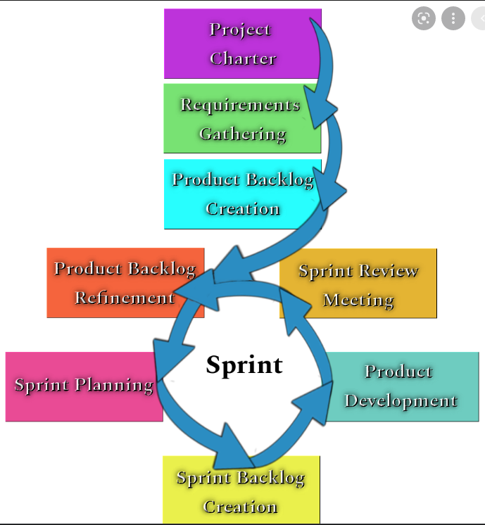

**Phase - 1: Requirement Gathering:** All the requirements have been consolidated the " SpecificationDocuments.doc" .

**Phase - 2: Product Backlog Creation:** We have defined 10 user stories from the Specification Document and dumped as product backlog.

**Phase - 3: Sprint Planning:** We have defined 3 sprints. Each sprint duration will be of 1 day. There are 3 story points in first and third sprint. Second sprint contains 4 story points.

**Phase - 4 : Product Development:** All the story points must be implemented as a part of Sprints on time.

**Phase - 5 : Sprint Retrospective:** Retrospective will be done "what went well & what not" and "what needs to be improved".

**Phase - 6 : Sprint Planning:** Planning will be done to decide the story points for next sprint.

**Phase - 7: Product Backlog Refinement:** Product Backlog Refinement ensures all the story points has been implemented.

***Sprint - 1***

|  |  |  |
| --- | --- | --- |
| **Title**  **US - 1**: Environment Setup | **Priority**  1 | **Estimate** |
| **User Story**  As a: Product Owner,  I want the environment should be ready prior to the development  So that showcase of the prototype will be given as per the timeline. | | |
| **Acceptance Criteria**  Get the environment ready to develop the prototype. Below are the areas need to be setup before development and presented to the relevant stakeholders.   * Eclipse/IntelliJ: An IDE to code for the application * Java: A programming language to develop the prototype * Git: To connect and push files from the local system to GitHub * GitHub: To store the application code and track its versions | | |

|  |  |  |
| --- | --- | --- |
| **Title**  **US - 2**: Develop flow chart and Algorithm | **Priority**  2 | **Estimate** |
| **User Story**  As a: Project Manager,  I want the Algorithm and flow chart should be prepared  So that approach towards the solution can be freezed. | | |
| **Acceptance Criteria**  Algorithm and flow chart should be ready before the development. | | |
| **Title**  **US - 3**: Welcome Screen | **Priority**  1 | **Estimate** |
| **User Story**  As a: User,  Code to display the welcome screen. It should display:  Application name and the developer details  The details of the user interface such as options displaying the user interaction information  Features to accept the user input to select one of the options listed | | |
| **Acceptance Criteria**  Welcome Screen should be displayed with below details, Application name and the developer details ,user interface details and options. | | |

|  |  |  |
| --- | --- | --- |
| **Title**  **US - 3**: Welcome Screen | **Priority**  1 | **Estimate** |
| **User Story**  As a: User,  Code to display the welcome screen. It should display:  Application name and the developer details  The details of the user interface such as options displaying the user interaction information  Features to accept the user input to select one of the options listed | | |
| **Acceptance Criteria**  Welcome Screen should be displayed with below details, Application name and the developer details ,user interface details and options. | | |

***Sprint - 2***

|  |  |  |
| --- | --- | --- |
| **Title**  **US - 4**: File names in ascending order | **Priority**  1 | **Estimate** |
| **User Story**  As a: User,  The first option should return the current file names in ascending order. The root directory can be either empty or contain few files or folders in it. | | |
| **Acceptance Criteria**  File names always be displayed in ascending order. | | |

|  |  |  |
| --- | --- | --- |
| **Title**  **US - 5**: Adding new file. | **Priority**  1 | **Estimate** |
| **User Story**  As a: User,  Option to add a user specified file to the application. Add a file to the existing directory list  You can ignore the case sensitivity of the file names | | |
| **Acceptance Criteria**  User should be able to add new files . | | |
| **Title**  **US - 6**: Adding new file. | **Priority**  1 | **Estimate** |
| **User Story**  As a: User,  Option to delete a user specified file from the application. Delete a user specified file from the existing directory list  You can add the case sensitivity on the file name in order to ensure that the right file is deleted from the directory list  Return a message if FNF (File not found) | | |
| **Acceptance Criteria**  User should be able to delete files and exception should be handled properly. | | |

|  |  |  |
| --- | --- | --- |
| **Title**  **US - 7**: Search a file | **Priority**  1 | **Estimate** |
| **User Story**  As a: User,  Option to search a user specified file from the application. Search a user specified file from the main directory  You can add the case sensitivity on the file name to retrieve the correct file  Display the result upon successful operation  Display the result upon unsuccessful operation | | |
| **Acceptance Criteria**  File names always be searched with given name. | | |

***Sprint - 3***

|  |  |  |
| --- | --- | --- |
| **Title**  **US - 8**: Code Integration | **Priority**  1 | **Estimate** |
| **User Story**  As a: User,  Integrate the individual function and the code.  Do a unit testing and ensure functionalities are working as expected. | | |
| **Acceptance Criteria**  Application should not close, exit, or throw an exception in direct flow.  Application should not close, exit, or throw an exception if the user specifies an invalid input. | | |

|  |  |  |
| --- | --- | --- |
| **Title**  **US - 09**: Return to main context | **Priority**  1 | **Estimate** |
| **User Story**  As a: User,  Navigation option to close the current execution context and return to the main context. Option to navigate back to the main context | | |
| **Acceptance Criteria**  User should be able to return to main menu. | | |

|  |  |  |
| --- | --- | --- |
| **Title**  **US - 10**: Close the application | **Priority**  1 | **Estimate** |
| **User Story**  As a: User,  Option to close the application | | |
| **Acceptance Criteria**  Application should be closed after every operation. | | |